Neighborhood assessment of stormwater harvesting potential: a simplified methodology examining the Garden District Neighborhood of Tucson, Arizona

Rod Pollock, rwpollock@email.arizona.edu
University of Arizona
GIST 909
December 2012

Abstract

Water in the desert is precious. Reclaiming rain through water harvesting is a way to maximize the use of available water. The purpose of this study was to formulate a methodology for local government to begin to assess their community for areas with enhanced potential for stormwater harvesting. This study is a pilot project that combines select GIS analyses to produce an “abstracted hydrology” that is optimized at a local, neighborhood-level scale. The methodology of this study creates a segment by segment snapshot of each street. In terms of the variables of street width, right-of-way widths, percent of vegetation canopy, percent of slope, and Shreve stream ordering magnitude, this snapshot illustrates cursory measurements fundamental to begin considering potential stormwater harvesting projects. The proposed methodology is realizable with existing GIS data, correlates newly created GIS data with existing, prevalent local GIS data, and is adaptable to additional variables of interest. This methodology is simplified yet dynamic and is ready to be applied to the assessment of additional neighborhoods. Employing this methodology, local government would have a tool to more effectively evaluate a neighborhood’s stormwater harvesting potential and have an enhanced opportunity to begin to take advantage of water harvesting in their community. This study explores sub-watershed prioritization and neighborhood-level analysis of stormwater harvesting potential focused on the Alvernon Wash sub-watershed impacting the Garden District Neighborhood in Tucson, Arizona.

Keywords: Arizona; Rainwater harvesting; Runoff collection; Stormwater runoff; Tucson; Water conservation; Water harvesting; Water reclamation; Water reuse

Introduction
Water in the desert is precious. Reclaiming rain through water harvesting is a way to maximize the use of available water. For the purpose of this study and to maintain consistency with the City of Tucson Water Harvesting Guidance Manual, “rainwater” becomes “stormwater,” once it has landed on a surface (City of Tucson Water Harvesting Guidance Manual 2005, p. v).

Water harvesting is the process of intercepting stormwater runoff from a surface (e.g. roof, parking area, land surface), and putting it to beneficial use. Intercepted stormwater can be collected, slowed down, and retained or routed through the site landscape using microbasins, swales and other water harvesting structures (City of Tucson Water Harvesting Guidance Manual 2005, p. 1).

Archeological evidence indicates the capture of rainwater as far back as 4,000 years ago. Ruins of cisterns built as early as 2000 B.C. for storing runoff from hillsides for agricultural and domestic purposes are still standing in Israel (Gould and Nissen-Petersen, 1999). The practice of water harvesting has been around a very long time. The benefits of water harvesting are perhaps more acutely understood by a desert community such as Tucson, as reported in the City of Tucson’s Water Harvesting Guidance Manual (2005, p. 26):

Water harvesting benefits the City and its residents by reducing the volume of stormwater flowing in streets or onto adjacent properties and by helping keep potential stormwater pollutants out of our watercourses and groundwater. Water harvesting reduces the amount of potable water used for irrigation, saving development costs and reducing the demands placed on the region’s potable delivery system and declining water table.

Despite all of the known benefits of water harvesting, “there are physical and legal challenges that impact our ability to use stormwater as a supplemental source including the variability of annual and seasonal rains, surface water rights, and water quality regulations” (City of Tucson and Pima County Stormwater Management Technical Paper 2009, p. [1]). Physical and legal challenges such as these can be substantial impediments for local government pursuing water harvesting in their communities.

In May of 2009, as part of Phase II of the City/County Water and Wastewater Study, the City of Tucson and Pima County evaluated how to best use stormwater and rainwater as a supplemental water source. This study found that the greatest potential for beneficial use of stormwater was at the lot and neighborhood scales.

Future development should be built to maximize the potential for use of stormwater at the neighborhood scale. Supporting vegetation using harvested stormwater will eliminate the need for some landscape watering. Stormwater flow paths can be depressed to encourage the potential for infiltration and native vegetation can be planted that will thrive in these depressed flow paths. Such a strategy will have the additional benefit of reducing flood peaks and improving stormwater quality (City of Tucson and Pima County Stormwater Management Technical Paper 2009, p. 28).

Understanding that water harvesting at the neighborhood-level has the potential to yield maximum benefits, what if local government wanted to begin to assess their community for areas with enhanced potential for stormwater harvesting?

The objective of this study was to formulate a methodology:
- For use by local government
- To assess specific neighborhoods within a community
- To discover areas with enhanced potential for stormwater harvesting

This study is a pilot project that combines select GIS analyses to produce an “abstracted hydrology” that is optimized at a local, neighborhood-level scale. The methodology of this study creates a segment by segment snapshot of each street. In terms of the variables of street width, right-of-way widths, percent of vegetation canopy, percent of slope, and Shreve stream ordering magnitude, this snapshot illustrates cursory measurements fundamental to begin considering potential stormwater harvesting projects. The exploration of these variables and their measurement is geographically set in the Garden District Neighborhood of Tucson, Arizona the drainage of which contributes to the Alvernon Wash sub-watershed in the Tucson basin of the Santa Cruz watershed.

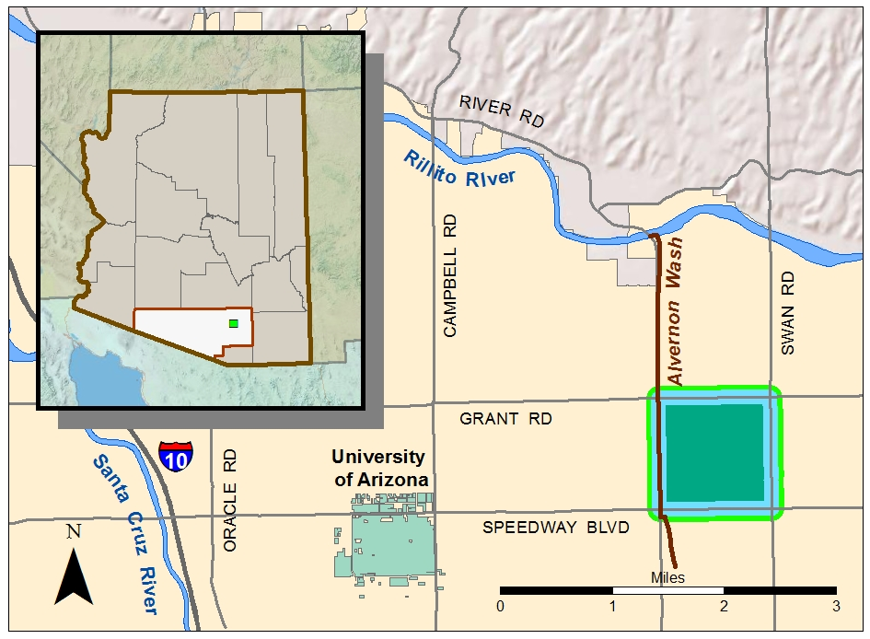
Figure 1. Garden District Neighborhood, Tucson, Arizona

Data and Variables
Water harvesting projects undertaken at the lot-level are primarily the domain of private property owners. Neighborhood-level water harvesting is the domain of local government. Water harvesting efforts at the neighborhood-level are relegated to public property, which is predominantly in proximity to the street network. Understanding that water harvesting at the neighborhood-level has the potential to yield maximum benefits, which streets within a given neighborhood would present the best opportunities for stormwater harvesting? Specifically focusing on the stormwater harvesting potential in proximity to a neighborhood’s street network, it is essential to understand:

- Street width (curb-to-curb)
- Right-of-way widths (back-of-curb/curb-to-parcel)
- Percent of vegetation canopy (parcel to parcel)
- Percent of slope (parcel to parcel)
- Shreve stream ordering magnitude

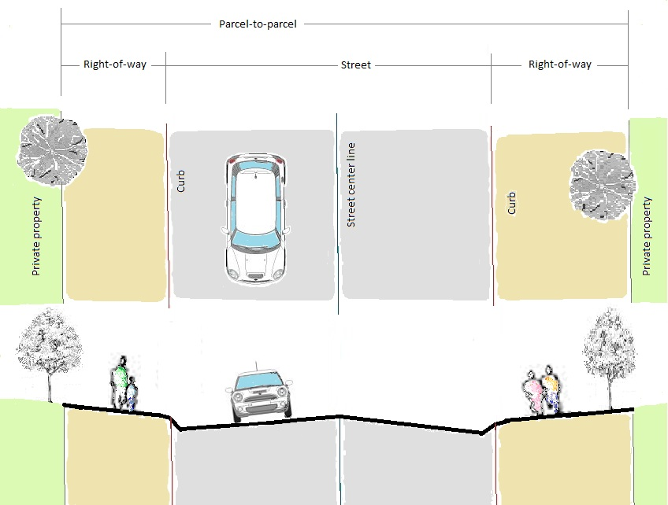

Figure 2. Measuring the study area

This study intentionally utilized GIS datasets that are commonly produced by local government entities and generally available, for free, for non-commercial use by the public. The primary data sets used in this study were shapefiles for the street network, curb network, and private property parcel data and raster files of a bare earth digital elevation model and a LiDAR-derived vegetation canopy. The data was projected according to the NAD 1983 HARN Arizona State Plane coordinate system. To explore stormwater harvesting potential in other geographic locations, similar datasets could be readily acquired locally. With an emphasis on practicality, for local governments wishing to explore this methodology, human labor would be the primary expense. Using ESRI ArcGIS 10.0, the primary datasets were geoprocessed in various ways to produce a “measurement” value for the five primary variables of street width, right-of-way widths, percent of vegetation canopy, percent of slope, and Shreve stream ordering magnitude. Ultimately, the analysis phase of this methodology will combine these five variables to form a “Stormwater Harvesting Equation.”
Unifying the geoprocessing results is the ROADID field. The “Road Identification” is a numeric descriptor assigned by Pima County that is an element of the GIS metadata for their street network shapefile. The ROADID uniquely identifies each street segment. Maintaining the common thread of the ROADID facilitates the segment-by-segment reporting of the results of the analysis of the proposed methodology. The common thread of the ROADID also insures contiguity with existing data sets maintained by Pima County, many of which are the local GIS standard. Associating new geoprocessing results with established metadata identifiers that are part of datasets commonly distributed throughout the local GIS community promotes the sharing of data and interoperability between datasets.

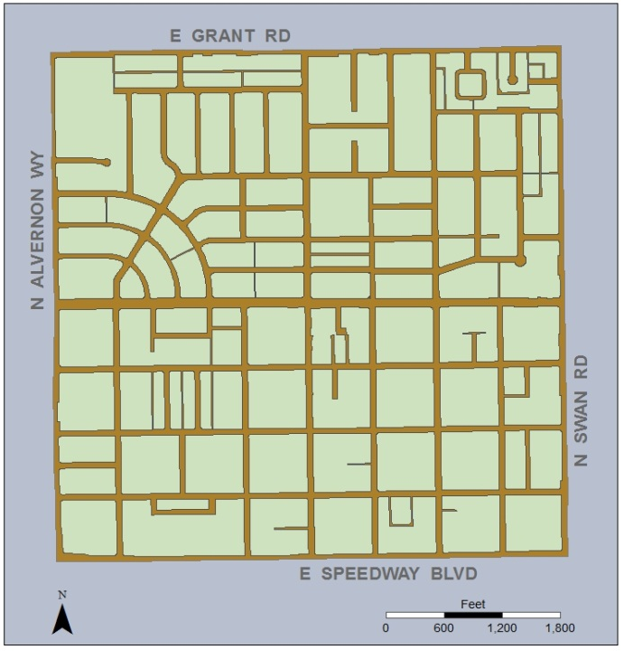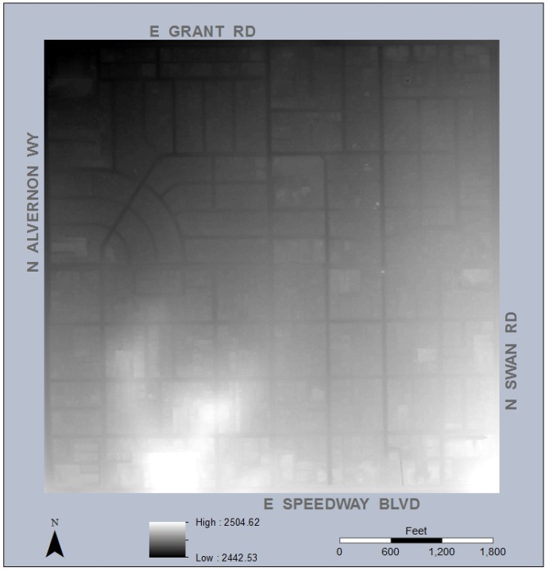
Figures 3 and 4. Garden District Neighborhood street network and bare earth digital elevation model

Geoprocessing - Creating the cross sections
The first step of this proposed methodology was to divide the street network with cross sections. Cross sections are necessary to be able to determine the width of the street and the distance from the street curb to the nearest private property parcel. Establishing the cross sections was accomplished using the River Bathymetry Toolkit (RBT) version 3.2.8.29. The River Bathymetry Toolkit is “a suite of GIS tools designed to interpret high-resolution DEMs of channels with a minimum of manual data manipulation” (RBT online help 2012). The River Bathymetry Toolkit was developed by ESSA Technologies Ltd. for the United States Forest Service and continues to be revised for use in the public domain. Available for free download, the River Bathymetry Toolkit can then be installed as an “add on” to the ESRI ArcGIS suite and be accessed through its own toolbar in ArcMAP. The River Bathymetry Toolkit was intended for use with rural rivers, not for use with urban streets. It is important to note that the River Bathymetry Toolkit can create cross sections based on only a single center line at one time. This limitation necessitated that the cross sections for the street network of the study area be created one street segment at a time. Creating the cross sections was mandatory and a relatively labor-intensive first step for a methodology intended to be simplified.
Figure 5. Cross sections
In terms of the Public Land Survey System, the Garden District Neighborhood in Tucson, Arizona equals one “section,” which is a square measuring one-mile by one-mile. The street network of this one-square-mile area includes 40 named streets. The manner in which these 40 named streets intersect, however, divide the street network of the study area into 192 separate segments. To emphasize each segment and more accurately characterize a street from parcel to parcel, intersections were not included in the cross section measurement. For this study, cross sections were created every 40 feet along each street segment. With this density of cross sections and without including street intersections, a total of 1,841 cross sections were required to dissect the streets of the Garden District Neighborhood.

Geoprocessing - Splitting the cross sections
To begin to be able to assess areas in proximity to a neighborhood’s street network in terms of potential for stormwater harvesting, it is necessary to determine the width of the street (the curb-to-curb distance) as well as the distance from the street curb to the nearest private property parcel (the right-of-way or back-of-curb distance). Originating at right angles from the center line, the cross sections extend through the curb lines to the nearest parcel line and, to prevent a dangling node, past the parcel line to a specified distance (usually 3 meters). The curb-to-curb distance and the back-of-curb distance can be discovered by splitting the cross section line where it intersects the curb line and where it intersects the parcel line. This study uses the average of these distances. Each street segment, however, has a cross section every 40 feet. This level of cross section density enhances the accuracy of averaging the curb-to-curb and back-of-curb measurements. Choosing to average these measurements emphasizes the “snap shot,” neighborhood-level overview this analysis is intended to provide. In the Garden District Neighborhood, the average street width was 34.6 feet and the average right-of-way width was 9.6 feet. The curb-to-curb average and the back-of-curb average are the first two variables of the “Stormwater Harvesting Equation.”

Geoprocessing - Creating the percent of vegetation canopy
Understanding the amount of existing vegetation canopy in proximity to the roadside is an important variable to the assessment of a neighborhood and its street network for potential stormwater harvesting. The vegetation data used for this study was based on one-meter 2007 NAIP four-band imagery. The tree canopy height data was generated from an analysis of LiDAR data from 2008. To discover the vegetation present between the parcel boundaries and the roadside, first, a parcel-to-parcel buffer polygon was created for each street segment. After geoprocessing the tree canopy raster to polygons, these two polygons were intersected with oneanother. The overlap of these polygons was expressed as the percent of existing vegetation canopy for each street segment. It is important to note that the vegetation canopy percentage did not take the height of the vegetation into account but was simply the percentage of the entirety of the vegetation present.
Figure 6. Vegetation canopy
The area under examination included the street and everything on either side of the street up to the private property boundary line. For this area in the Garden District Neighborhood, the total vegetation canopy amounted to only 9 percent. Generally, the vegetation in proximity to the roadside in the Garden District Neighborhood is not very dense. Characterizing the existing vegetation canopy in terms of a percentage for each street segment is not a substitute for the definitiveness of a detailed land survey. This measurement does, though, afford a perspective useful to forming expectations regarding the general density of roadside vegetation. The percent of vegetation canopy is the third variable of the “Stormwater Harvesting Equation.”

Geoprocessing - Creating the percent of slope
Steeply sloped areas can be problematic for some water harvesting techniques simply because the water moves too fast to control in a meaningful way. Generally, areas with a longitudinal slope of three percent or less have the most potential for the introduction of street water harvesting infrastructure. To discover the percent of slope for each street segment, first, the ArcGIS 10.0 Slope Tool was run on a bare earth raster of the entire Garden District Neighborhood. For the value generated in this geoprocessing step, “percent of slope” was specified rather than “degree of slope.” The percent of slope for each cell was recorded in the “GRID_CODE” field of the resulting raster file. Before moving on to the next geoprocessing step, the new raster file needed to be converted to a polygon. In order to convert this raster to a polygon, the “percent of slope” value for each cell was necessarily changed to an integer, which was best accomplished using the Integer Tool. After geoprocessing the “percent of slope” raster to polygons, these polygons were intersected with the parcel-to-parcel buffer polygons used to determine the percent of vegetation canopy for each street segment in the last step. Finally, the Dissolve Tool was used to calculate the average of the percent of slope for each street segment based on the ROADID field.
It is important to note that the “percent of slope” numeric figure is the average of the percent of slope from parcel boundary to parcel boundary. For each street segment, this includes the right-of-way on both sides of the street as well as the street itself. Also included in this area are the street gutters, the network of which has the cells with the steepest slope. Averaging the percent of slope in this manner is intended to roughly reflect a street’s longitudinal slope, which is the gradient of a street from end to end and is a crucial measurement to the engineering of a street. The area under examination included the street and everything on either side of the street up to the private property boundary line. For this area in the Garden District Neighborhood, the average percent of slope was 3.6 percent. Generally, the slope in proximity to the street network in the Garden District Neighborhood is not flat but relatively gently sloped. The percent of slope is the fourth variable of the “Stormwater Harvesting Equation.”

Geoprocessing - Creating the stream order for the street network
Depicting the street network as a “stream” reflects the flow direction and flow accumulation of water through the roadways of the Garden District Neighborhood instead of between the banks of a river through the countryside. To begin to define the street network as a “stream,” it is necessary to create a stream line raster. With a relatively high quality digital elevation model (DEM), the stream line raster will roughly match up with the street network. This study used a DEM with a resolution of 3 meters. To further refine the stream line raster, it is also necessary to apply a “conditional” statement. For this study, the resulting conditional raster included cells with a flow accumulation value greater than 1000, cells with a value of 1, and cells with a value of 0. With a satisfactory stream line raster, the stream ordering tool can be utilized.

Stream ordering is a method of assigning a numeric order to links in a stream network. This order is a method for identifying and classifying types of streams based on their numbers of tributaries. Some characteristics of streams can be inferred by simply knowing their order (ESRI ArcGIS 10.0 Stream Ordering Tool, tool help file, 2012).

This study focused on a single neighborhood. This neighborhood’s street network, however, is only a part of a much larger street network. In an effort to more adequately define the boundaries of the study area, it was important to account for all of the links in the stream network. This was accomplished by employing the Shreve stream ordering method.

The Shreve stream ordering method accounts for all links in the network. All exterior links are assigned an order of 1. For all interior links in the Shreve method, the orders are additive. For example, the intersection of two first-order links creates a second-order link, the intersection of a first-order and second-order link creates a third-order link, and the intersection of a second-order and third-order link creates a fifth-order link (ESRI ArcGIS 10.0 Stream Ordering Tool, tool help file, 2012).

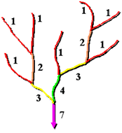
After successfully running the stream order tool, each street segment is then defined by a Shreve stream order “magnitude.” The Shreve stream ordering method produces a single, additive number for each segment in the network. This number, or magnitude, is the number of upstream links. With regard to the methodology of this study, the upstream links are the street segments whose water flow and accumulation is directed to the segments with a higher Shreve magnitude. Within the geographic constraints of the study area, the street segments with a higher Shreve magnitude can be readily recognized as having an increased hydrologic probability for water accumulation. It is also valuable to be able to identify street segments with a lower Shreve magnitude. The first principle of water harvesting is to begin harvesting water at the “top” of the watershed over which you have control. By managing small volumes of water at the top and throughout the watershed, the need to manage a large volume of stormwater at the bottom of the watershed is decreased (City of Tucson Water Harvesting Guidance Manual 2005, p. 2). Defining street segments in the concise terms of the Shreve stream ordering method is not a substitute for a comprehensive hydrological survey. This measurement does, though, provide a useful synopsis of the direction and accumulation of water flow through the street network. The Shreve stream ordering magnitude is the fifth variable of the “Stormwater Harvesting Equation.”
Figure 7. The Shreve stream ordering method (ESRI ArcGIS 10.0 Stream Ordering Tool, tool help file, 2012)

The results of this proposed methodology are based on evaluating each segment in the existing street network. Evaluating each segment in the existing street network includes acknowledging portions of that network that are not applicable to be measured. Primarily, these were segments with no curbs, segments in the middle of an intersection, and/or segments with no private property boundaries. There were 192 street segments in the Garden District Neighborhood. Generating new GIS data for five primary variables has the potential to create 960 new measurements. Accounting for and removing the anomalies particular to each variable, this methodology’s geoprocessing still produced 871 street segments with viable measurements. That is, 91 percent of the street segments in the Garden District Neighborhood were successfully measured in terms of at least one of this methodology’s primary variables. One hundred and sixty five unique values were generated, averaging 33 unique values for each of the five primary variables. This methodology provides all of the measurements for all of the variables for each street segment. Considering this dynamic, this methodology literally provides millions of ways to combine the five primary variables to define street segments in terms of their stormwater harvesting potential.

 | Street segment total | Street segment total minus anomalies particular to variable | Unique values | Measured in | Min | Max | Average
Street width  (curb-to-curb) | 192 | 166 | 22 | Feet | 24 | 49 | 36.5
Right-of-way widths  (back-of-curb/curb-to-parcel) | 192 | 171 | 16 | Feet | 2 | 17 | 10.4
Vegetation canopy  (parcel to parcel) | 192 | 187 | 27 | Percent | 0 | 34 | 8.8
Slope  (parcel to parcel) | 192 | 187 | 48 | Percent | 1.9 | 9.5 | 3.7
Shreve stream ordering magnitude | 192 | 160 | 52 | # of upstream links | 1 | 250 | 29.4

Table 1. Five primary variables with geoprocessing results

Analysis and Results
Each variable of this methodology has a set of unique values. From these unique values, the analysis necessitates that a “threshold value” be chosen. This value can be flexible and varied to optimize results in accordance with the immediate stormwater harvesting objective. The thresholds for all of the variables that are part of this study are inherently arbitrary. However, when considering engineering and city planning, some are more arbitrary than others. In the context of a practical, primary set of variables and threshold values, this analysis demonstration isolates street segments within the Garden District Neighborhood with high Shreve stream ordering magnitude values as well as low Shreve stream ordering magnitude values. The results of this analysis are based on street segments exhibiting:

- Slope of 3 percent or less
- Width of street between 30 and 40 feet
- Vegetation canopy of less than 20 percent
- Right-of-way average of 12 feet or more
- Higher Shreve stream ordering magnitude (Lower in the watershed)
- Lower Shreve stream ordering magnitude (Higher in the watershed)

Longitudinal slope and curb-to-curb width are characteristics that readily separate streets as being favorable for stormwater harvesting. Streets with a longitudinal slope of 3 percent or less can successfully accommodate a wider array of water harvesting techniques. On-street parking generally trumps water harvesting in the eyes of city planners. Introducing water harvesting techniques on streets that are less than 30 feet in width would have the potential to negatively impact on-street parking. Streets that are 40 feet or wider are typically commercial and occasionally do not have curbs. Streets between 30 and 40 feet wide, typically residential, not main thoroughfares and with an existing right-of-way, have the greatest potential for stormwater harvesting. These thresholds for longitudinal slope and curb-to-curb width establish these variables as foundational elements upon which further analysis is based.
The thresholds for the other variables are relatively arbitrary. That is, there is no hard, fast rule for the preferable amount of right-of-way space or vegetation canopy nor for an ideal Shreve stream ordering magnitude value. These thresholds, and, indeed, the variables, are flexible depending on the immediate stormwater harvesting objective. A vegetation canopy of less than twenty percent would facilitate new construction and would benefit from the introduction of native vegetation. A right-of-way average of twelve feet or more would offer an array of options for more and larger water harvesting techniques. Street segments with higher Shreve stream ordering magnitude values will have a greater accumulation of water flow and perhaps be better suited for more robust water harvesting techniques possibly including water basin construction. Street segments with lower Shreve stream order magnitude values are higher in elevation in relation to the watershed. Water harvesting higher in the watershed reduces the amount of water accumulation lower in the watershed. Also, the decreased flow levels of segments higher in the watershed can accommodate numerous proven water harvesting techniques. For this study’s demonstrated analysis, the thresholds employed for the percent of vegetation canopy, the right-of-way width, and the Shreve stream ordering magnitude are arbitrary. These thresholds do, however, accurately characterize the manner in which these variables are intended to be combined.

The Snapshot
Of the 192 total street segments, there were 43 that:
- Had a slope of 3 percent or less
- AND, were between 30 and 40 feet in width

Of those 43, there were 21 street segments that:
- Had a slope of 3 percent or less
- Were between 30 and 40 feet in width
- AND, had a right-of-way average of 12 feet or more

Of those 21, there were 16 street segments that:
- Had a slope of 3 percent or less
- Were between 30 and 40 feet in width
- Had a right-of-way average of 12 feet or more
- AND, had a vegetation canopy of less than 20 percent

Of those 16, there were 14 street segments that:
- Had a slope of 3 percent or less
- Were between 30 and 40 feet in width
- Had a right-of-way average of 12 feet or more
- Had a vegetation canopy of less than 20 percent
- AND, had a Shreve magnitude of 8 or less

Also out of the final 16 street segments, there were 2 street segments that:
- Had a slope of 3 percent or less
- Were between 30 and 40 feet in width
- Had a right-of-way average of 12 feet or more
- Had a vegetation canopy of less than 20 percent
- AND, had a Shreve magnitude of 20 or more

 |  | Variable |  | Threshold
 | Street segments with | Slope |  | 3 percent or less
and | Street segments with | Width of street |  | Between 30 and 40 feet
and | Street segments with | Vegetation canopy |  | Less than 20 percent
and | Street segments with | Right-of-way |  | 12 feet or more
and | Street segments with | Shreve stream ordering magnitude |  | Greater than 20
or | Street segments with | Shreve stream ordering magnitude |  | Less than 8
= | Shreve values > 20  (segments lower in the watershed) |  | Shreve values < 8  (segments higher in the watershed)
 | ROADID |  | ROADID
 | 23687 |  | 47293 |  | 53822 | 32845
 | 4200 |  | 20257 |  | 34025 | 26827
 |  |  | 26061 |  | 45609 | 33334
 |  |  | 29480 |  | 47677 | 31474
 |  |  | 56684 |  | 43641

Table 2. The Stormwater Harvesting Equation

This combination of variables and associated thresholds indicates that there are two street segments (the two segments with the higher Shreve order magnitude values) that have enhanced candidacy for more robust water harvesting techniques, including possibly the introduction of a stormwater basin.
This combination of variables also indicates that there are fourteen street segments (those segments with the lower Shreve order magnitude values) that have enhanced candidacy for an array of proven water harvesting techniques all of which would favorably impact the lower regions of the neighborhood watershed.
The street segments showing the greatest potential for stormwater harvesting efforts are specified by their ROADID, an element of the GIS metadata for the street network shapefile compiled by Pima County. Each street segment is uniquely identified by its ROADID.

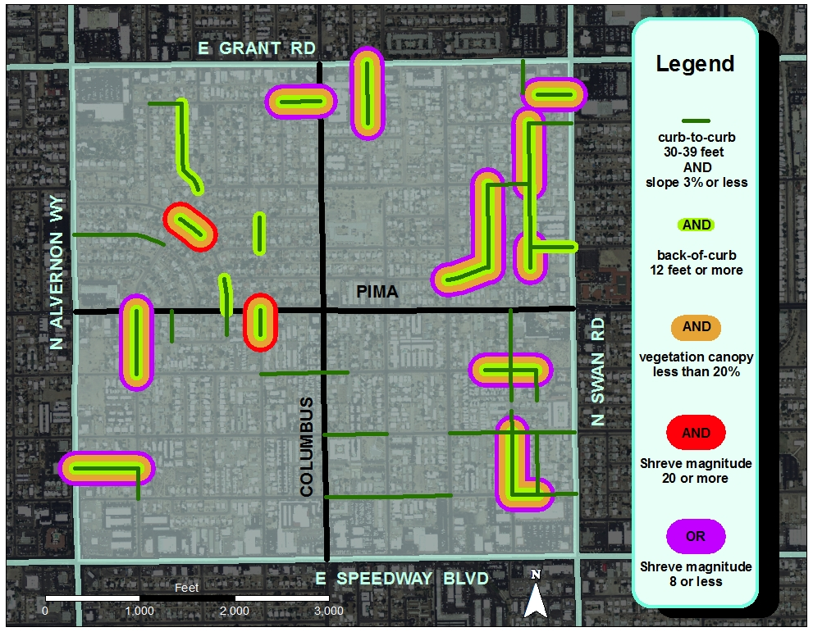
Figure 8. Analysis results in the geographic context of the Garden District Neighborhood

The five primary variables of street width, right-of-way widths, percent of vegetation canopy, percent of slope, and Shreve stream ordering magnitude could be combined in any number of ways. Variables reporting additional measurements of interest (e.g. stormwater infrastructure data, pervious/impervious ground cover data, etc.) could easily be added for a more faceted analysis. The measurements used in this analysis are principally finite, current, and accurately representative of the Garden District Neighborhood. With a goal of harvesting stormwater, there are many levels of inquisition that would be productive. That is, a single panacea comprehensively resolving all problems associated with water harvesting does not exist. Being aware that a street segment is higher in the neighborhood watershed and could benefit the entire watershed with the introduction of even a single, minor water harvesting technique is good but there are still myriad opportunities for water harvesting within the very same neighborhood. The results of this manner of reductive analysis are rightfully subjective and dependent on the variables included and their associated thresholds.

Conclusion
The purpose of this study was to formulate a methodology for use by local government to begin to assess specific neighborhoods within a community for areas with enhanced potential for stormwater harvesting.

Methodology
- Determine variables pertinent to stormwater harvesting
- Acquire existing local datasets
- Extract new measurements through geoprocessing in ArcGIS
- Unify variables in terms of the existing street network using the ROADID field
- Combine the variables in a “Stormwater Harvesting Equation”
- Analyze each street in a neighborhood segment by segment

Exploring these variables, on this scale, in these geoprocessing terms is a valid first step to the production of a tool for local government to use to begin to consider stormwater harvesting projects. However, the completion of this study, at this time, undeniably left room for improvement. Creating the cross sections for the street network was extremely labor intensive. A more efficient method of creating cross sections for the street network would be a vast improvement. Measuring the “percent of slope” could be refined by removing the street gutter network from the bare earth raster prior to calculating the slope. When creating the stream order, including the street network of the area immediately surrounding the study area would further refine the computing of the Shreve stream ordering magnitudes.
The stormwater harvesting “equation” can only tell the story of the variables available. The present state of this “abstracted hydrology” could be enhanced by the inclusion of stormwater infrastructure data (storm drains, etc.) as well as pervious/impervious ground cover data.
The geoprocessing required for this study was necessarily a manual process. The proposed methodology could possibly be improved with the development of an ESRI ArcGIS “model” that might automate some steps of the processing and/or analysis.
Ideally, street segments would be classified in terms of the study variables (street width, right of way width, slope, pervious/impervious ground cover, etc.). Street segments (and their particular combination of study variables) could then begin to be associated with the optimum water harvesting technique or techniques (e.g. microbasins, swales, French drains, gabions, etc.). Water harvesting techniques are well-documented and could be defined, depending on size, in terms of construction cost. Associating street segments with water harvesting techniques and the cost of these water harvesting techniques, local government could begin to formulate a cost/benefit analysis for stormwater harvesting projects.
Acknowledging all of these possibilities for improvement, this methodology is still primarily successful because it is simplified, yet dynamic.

Simplified
- Realizable with existing GIS data
- GIS processing and measurement of variables optimized at a neighborhood-level scale
- The analysis is granular, results can be specified by individual street segments

Dynamic
- Just five primary variables demonstrate the power and flexibility of The Stormwater Harvesting Equation
- Newly created GIS data is correlated with existing, prevalent local GIS data
- The analysis is adaptable to additional variables of interest
- Ready to be applied to the assessment of additional neighborhoods

It is interesting to note that, while geoprocessing the slope data for this study, the drainage of the street network in the Garden District Neighborhood was very thoroughly accounted for. That is, within the street network, the gutter system on either side of the street was clearly defined in terms of water flow. Which is to say that the engineering that went into the construction of the drainage system in the Garden District Neighborhood was, and is, generally very good. Yet, some streets still flood during rainstorms. This is evidence that there is room for improvement with regard to the drainage infrastructure. Stormwater harvesting has the potential to play an important role in drainage infrastructure, including the mitigation of street flooding, while simultaneously positively impacting a community’s quality of life.

References
City of Tucson and Pima County Stormwater Harvesting Technical Paper for The Water and Wastewater Infrastructure, Supply and Planning Study, Phase II. 2009. http://www.tucsonpimawaterstudy.com/Reports/Phase2/Stormwater.Mgt.Tech.Paper.pdf (last accessed 11/15/2012)

City of Tucson Water Harvesting Guidance Manual. 2005. http://cms3.tucsonaz.gov/files/transportation/2006WaterHarvesting.pdf (last accessed 11/24/2012)

ESRI ArcGIS 10.0 Stream Ordering Tool, tool help file (last accessed 11/11/2012)

Gould J, Nissen-Petersen E. 1999. Rainwater catchment systems for domestic rain: design construction and implementation. London: Intermediate Technology Publications. 335p.

McKean, J., Nagel, D., Tonina, D., Bailey, P., Wright, C.W., Bohn, C., Nayegandhi, A. 2009. Remote sensing of channels and riparian zones with a narrow-beam aquatic-terrestrial lidar. Remote Sensing, 1, 1065-1096; doi:10.3390/rs1041065.

River Bathymetry Toolkit online help http://www.essa.com/tools/RBT (last accessed 11/11/2012)

Texas Water Development Board. The Texas Manual on Rainwater Harvesting. 2005. Third Edition. Austin, TX http://www.twdb.state.tx.us/publications/reports/rainwaterharvestingmanual_3rdedition.pdf (last accessed 11/15/2012)

