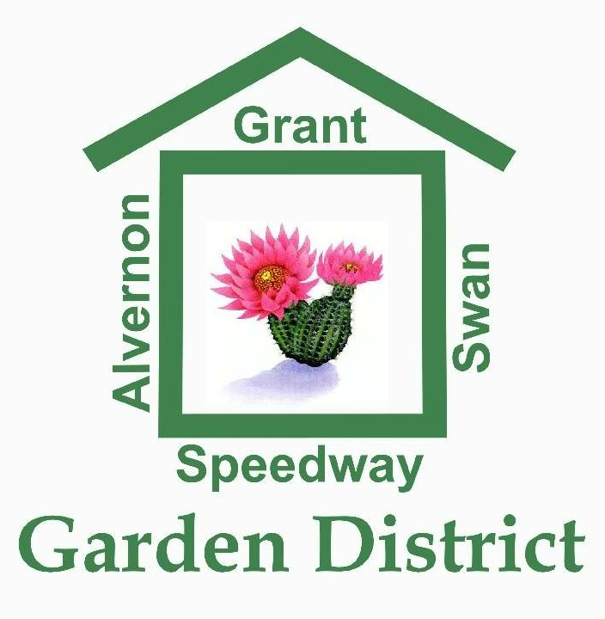

NOMINATION FORM FOR
2018 GARDEN DISTRICT NEIGHBORHOOD ASSOCIATION BOARD
Due Date: Jan. 9,, 2018

My name is ___________________________________ .. My primary residence is within the boundaries of Garden District Neighborhood (Swan to Alvernon, Grant to Speedway) and is located at ____________________________________________.

I would like to nominate _________________________________________for the position of ______________________ on the 2018 Garden District Neighborhood Association Board. To my knowledge, this individual is an adult 18 years or older, has their primary residence within Garden District boundaries and has attended at least two of the four quarterly GDNA meetings and one social event or neighborhood volunteer opportunity during the previous calendar year.

Comments and Nominee’s Contact Info if you have it: (optional)

________________________________________________________
Signature

________________________
Date

Give this from either to a current GDNA Board member or mail to the current Board President Lois Pawlak, P.O. Box 32384, Tucson, AZ 85751 or send an email with this information to mmcjohnson@cox.net

